University Of Engineering and Technology, Lahore
Computer Engineering Department

Course Name: Programming Fundamentals | Course Code: CMPE-112L
Assignment Type:Lab Tasks | Dated: 27-04-2026
Semester: 1st | Session: Spring
Lab/Project/Assignment #: 7 | CLOs to be covered: CLO 3
Lab Title: Lists and Tuples | Teacher Name: Hafiz Muhammad Mubashar
Lab Evaluation:

CLO1 | Apply appropriate programming techniques to create executable programs to solve well defined problems
 | Level1 | Level2 | Level3 | Level4 | Level5 | Level6
(5)
Total |  |  |  |  |  | /5
Rubrics for Current Lab Evaluation
Scale | Marks | Level | Rubric
Excellent | 5 | L1 | Submitted all lab tasks, BONUS task, have good understanding.
Very Good | 4 | L2 | Submitted the lab tasks but have good understanding
Good | 3 | L3 | Submitted the lab tasks but have weak understanding.
Basic | 2 | L4 | Submitted the lab tasks but have no understanding.
Barely Acceptable | 1 | L5 | Submitted only one lab task.
Not Acceptable | 0 | L6 | Did not attempt
LAB No 7
Lab Goals/Objectives:
To learn list and tuple operations in Python.
Equipment Required:
Computer or Laptop, Python 3.x, PyCharm or VS Code.
Theory:
Lists store editable data while tuples store fixed data. Both are used to manage collections of values.

Lab Work:
Task 1: Find the largest and smallest number in a list.
Result:
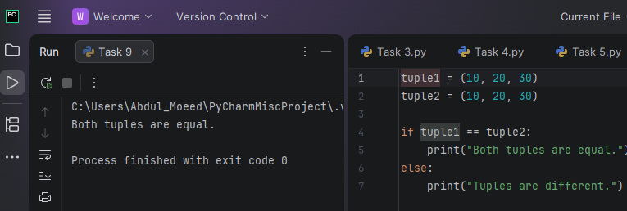
Task 2: Search an element in a list.
Result:
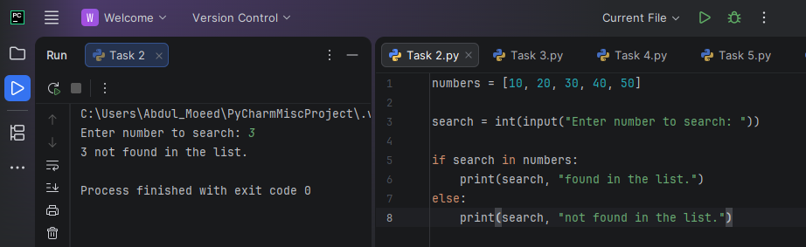
Task 3: Remove duplicate values from a list.
Result:
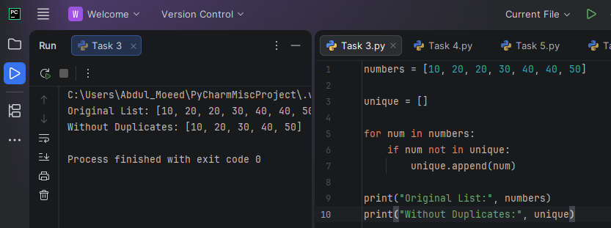

Task 4: Store marks in a list and calculate highest and average.
Result:
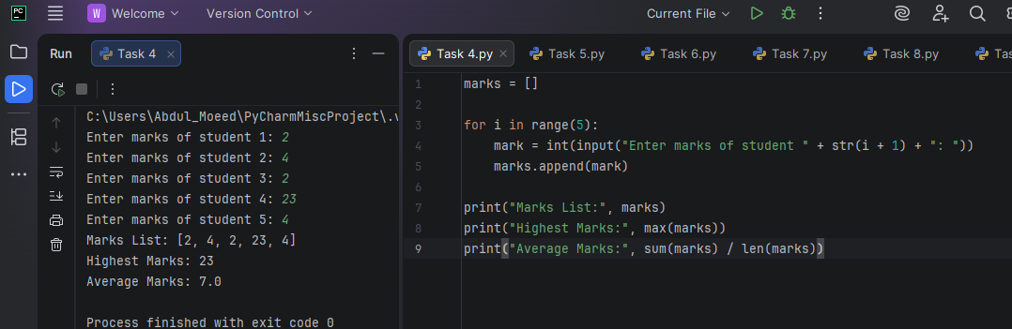
Task 5: Sort a list in ascending order.
Result:
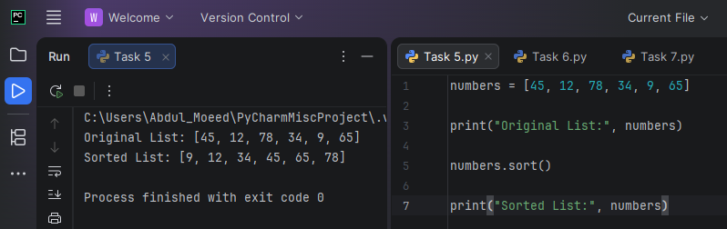

Task 6: Count occurrences of a value in a tuple.

Result:
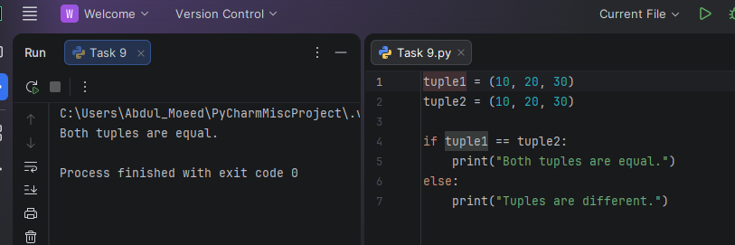

Task 7: Find the index of an element in a tuple.
Result:

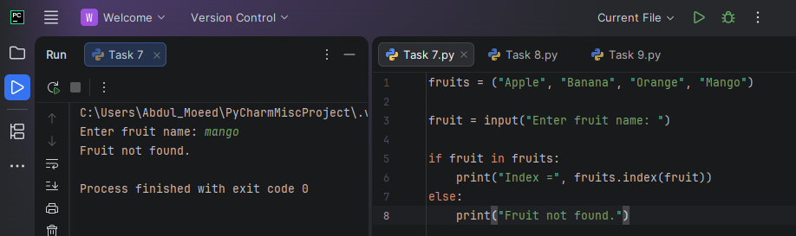

Task 8: Display student information using a tuple.
Result:
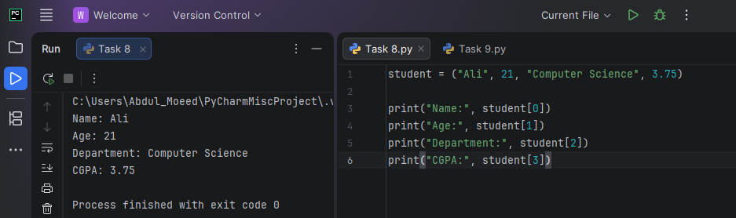

Conclusion:
The lab improved understanding of Python lists, tuples, and their basic operations.

